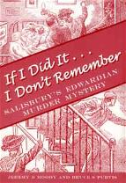If I Did it, I Don’t Remember: Salisbury’s Edwardian Murder Mystery, by Jeremy B Moody and Bruce S Purvis.
NEW BOOK
BY FROGG MOODY & BRUCE S. PURVIS
Foreword by Robin Odell

For details and how to order your copy,
email Frogg Moody on;
frogg@timezonepublishing.com
Salisbury, October 31st 1908. This date heralded Salisbury’s most infamous murder case, unsolved to this day. A young boy lay dead, his mother was arrested for the murder, and Scotland Yard was brought in to help investigate. Enter Chief Inspector Dew, who had hunted Jack the Ripper and in 1910, would arrest the notorious Dr Crippen to gain worldwide fame – Scotland Yard’s first international superstar! The authors have spent three years researching this case, which attracted international media attention a century ago. Their meticulously documented account includes previously unidentified scene of crime photographs, the personal thoughts of Chief Inspector Dew and fascinating new evidence. 264 pages, maps and contemporary illustrations, paperback, £12.95, ISBN 978-0-946418-78-7.

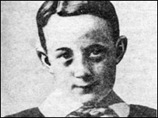
Murdered child Edwin 'Teddy' Haskell

Salisbury's unsolved murder mystery
A new book throws light on Salisbury's most famous unsolved crime - the murder of 12-year-old Teddy Haskell in 1908.
Salisbury, October 31st 1908. This date heralded Salisbury's most infamous murder case, still unsolved to this day.
A young boy lay dead, his mother arrested for the murder and Scotland Yard brought in to help investigate. Enter Chief Inspector Dew who had hunted Jack the Ripper and arrested the notorious Dr. Crippen and gained worldwide fame.
Twelve-year-old Edwin 'Teddy' Haskell was a popular boy in Fisherton, the suburb of Salisbury, Wiltshire, where he lived with his widowed mother.
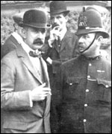
Investigator Chief Inspector Walter Dew.
Six years earlier he had contracted tuberculosis, which resulted in his leg being amputated above the knee. Everyone admired the pluck of this cheerful lad who got around on his crutches and even managed to play football with his pals.
The shock and sadness that followed news of Teddy's tragic death in his own home in 1908 was palpable. The manner of his death was particularly brutal; his throat was cut while he lay in bed.
Suspicion soon fell on his mother, Flora Fanny Haskell, who's early statements contradicted those of other witnesses. Her blood-stained clothing, like her bewildered denials, would be subjected to intensive forensic scrutiny in two trials for murder when her own life was at stake.
This story which shook the local community to its roots and gripped the nation is set out in all its forensic and social detail by Jeremy B. Moody and Bruce S. Purvis in their newly published book entitled 'If I did it...... I don't remember'. These were Flora Haskell's own words, as spoken to a prison wardress.
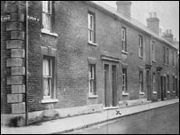
40 Meadow Road, where the murder was committed.
The book paints a graphic picture of suburban Edwardian life and revisits a crime that the passage of time had relegated to a backwater. In setting the scene, the book shows that the murder of Teddy Haskell and its investigation and prosecution drew in an impressive assembly of dramatis personae.
Chief Inspector Walter Dew, approaching his moment of fame in the arrest of Dr Crippen, was called in from Scotland Yard to boost the police investigation of the crime scene.
Dr Augustus Pepper, consultant surgeon of considerable distinction and a Home Office expert, would defend his deductive skills in court against the incisive examination of Rayner Goddard, a future Lord Chief Justice of England.
And Flora Haskell's second trial for murder would be presided over by Mr Justice Darling, a judge whose reputation for wit endeared him to court reporters.
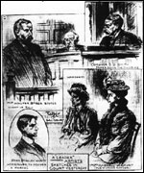
Line drawing of Flora Fanny Haskell in court.
The progress of the Haskell case was comprehensively reported in the newspapers of the day. The essential elements of a lone woman in a state of obvious distress accused over the death of her crippled boy tugged at the heart strings of the nation.
In an age when newspapers were the only media, all the comings and goings at the trial proceedings were reported in great detail.
At the heart of the story is the dedication of a hard-working mother to her handicapped son. In court, a witness described her as, 'Everything a mother ought to be, she was'.
In the end, after two trials in Devizes, the jury finally found Flora Fanny Haskell not guilty through lack of evidence and she was a free woman. The case remains unsolved to this day.
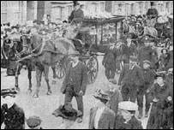
The funeral procession in Devizes Road, Salisbury.
'If I did it...... I don't remember: Salisbury's Edwardian Murder Mystery' by Jeremy B. Moody and Bruce S. Purvis is published by Hobnob Press

