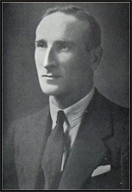

Australia’s writers showed their claws,
Her backers raged, her batsmen shook,
Statesmen consulted – and the cause?
Our bowling was too good to hook.

D.R. Jardine, 1933.

